Congratulations to Kristina Kalinina on the successful defense of her doctoral thesis.

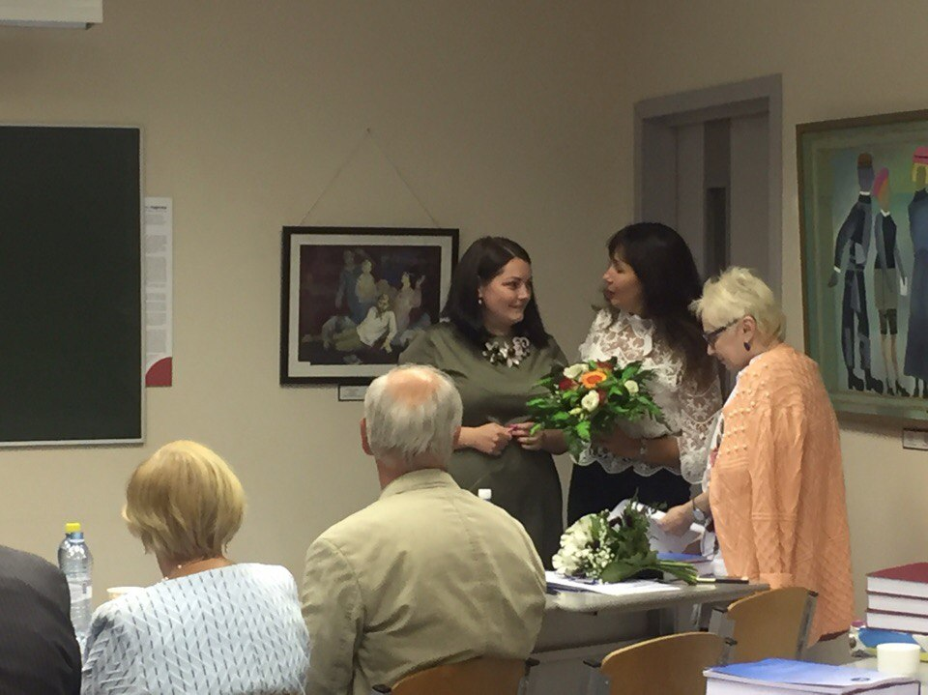

Administration and
Academic staff of the BIA

