Strengthening of international cooperation of BIA.
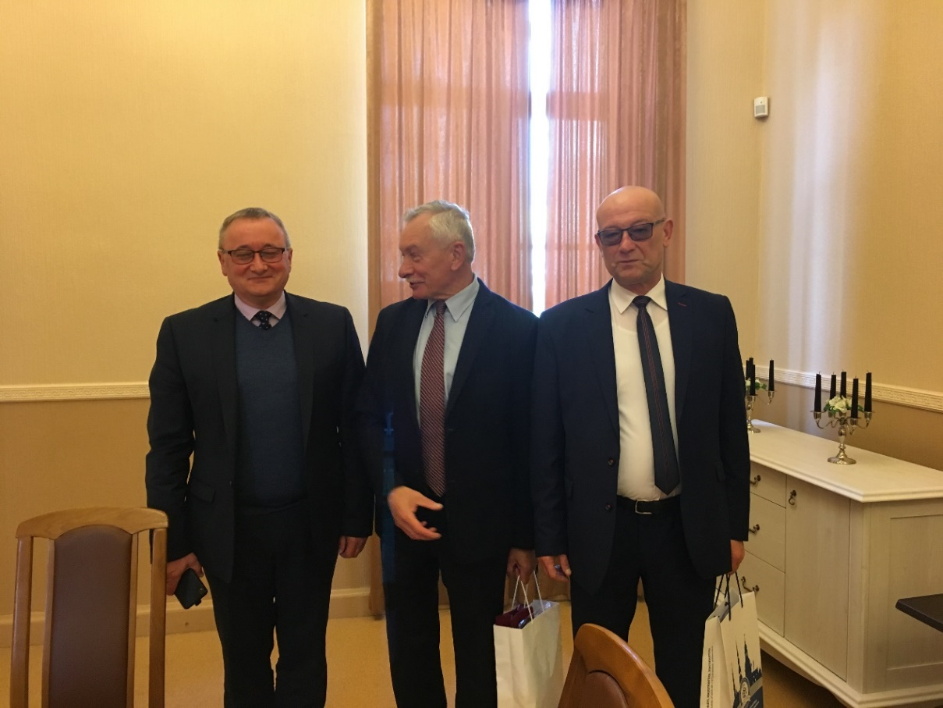
09/21/2017. There was a meeting with the chairman of the Senate S. А. Buka with professors Mariusz Kubiak and Mirosław Minkina from Siedlce University of Natural Sciences and Humanities (Poland).
As a result of the meeting were discussed further scientific cooperation and also exchange lecturers and students of the university.

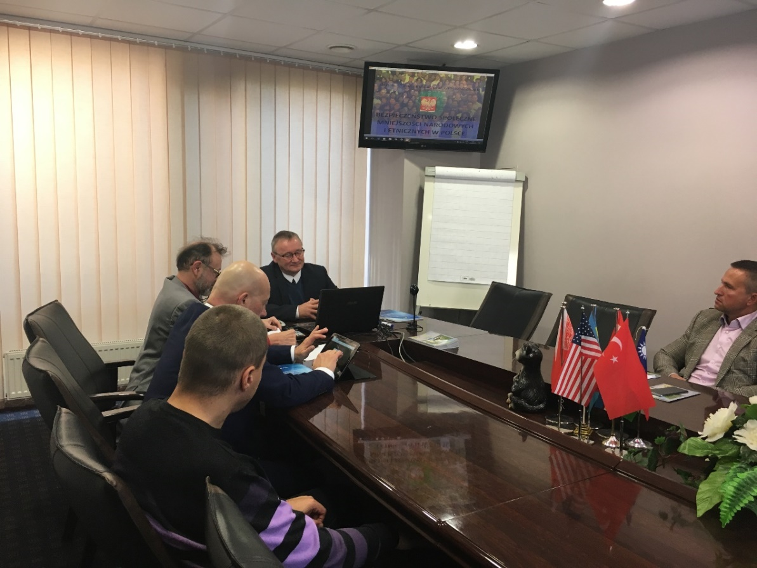
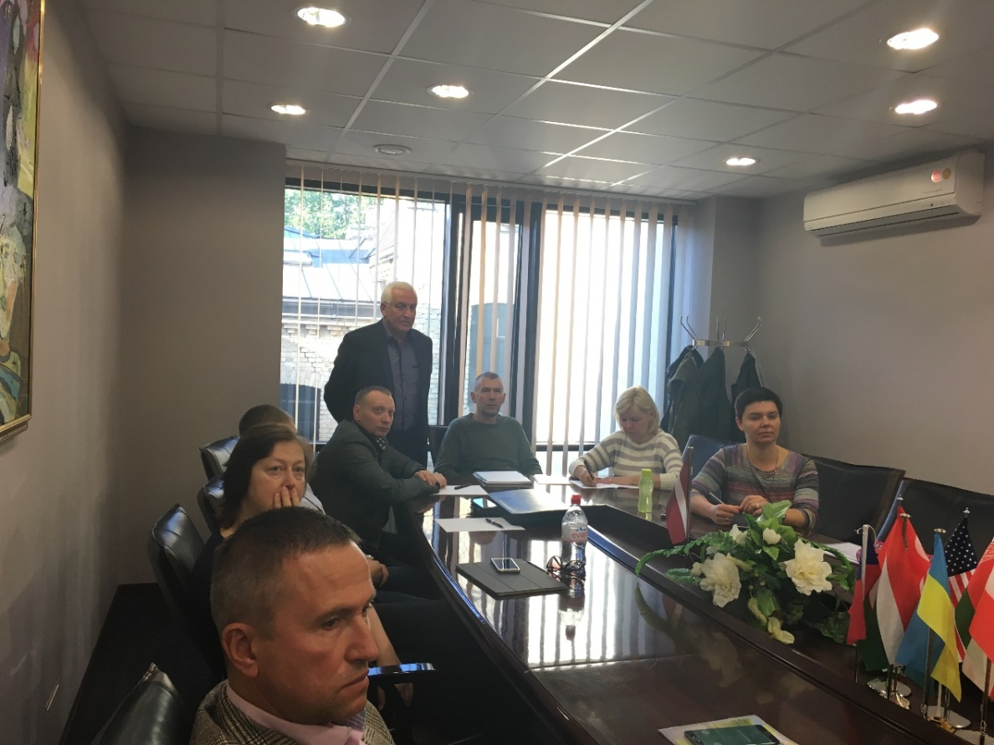
09/23/2017. a lecture was held for students of doctoral programs "Regional Economic and Economic Policy" and "Legal Science". The lecture was conducted by professors from Siedlce University of Natural Sciences and Humanities (Poland) dr hab. prof. Mirosław Minkina, dr hab.prof. Mariusz Kubiak and dr hab.prof. Jacek Zielinsky.

