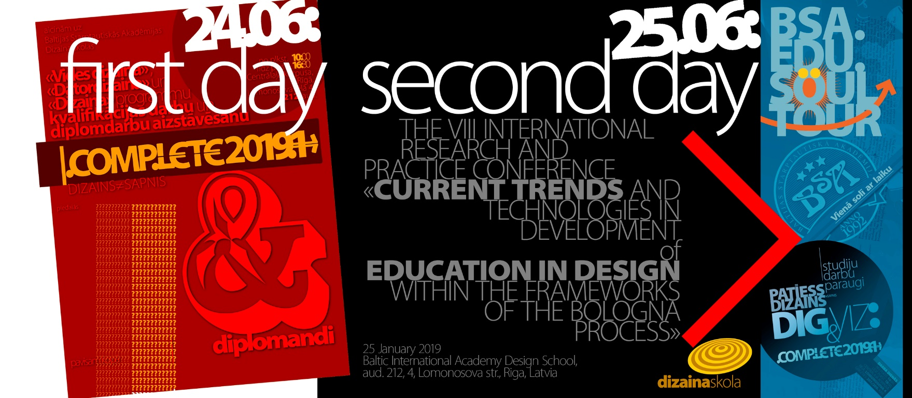

We are announcing
THE 8th INTERNATIONAL RESEARCH AND PRACTICE CONFERENCE
«CURRENT TRENDS AND TECHNOLOGIES IN DEVELOPMENT OF EDUCATION IN DESIGN WITHIN THE FRAMEWORKS OF THE BOLOGNA PROCESS»
to be held on January 25, 2019 at Baltic International Academy at the address 4, Lomonosov str., Riga, Latvia
The events associated with the conference will be held on 24, 25, 26 January

BIA DS in partnership with
Design Department, Faculty of Arts, Kaunas Justinasa Vienožinskisa Colledge (Kaunas, Lithuania) | Kauno Kolegija, Technologijų ir Kraštotvarkos Fakultetas, Medijų Technologijų Katedra
Faculty Of Education, Department Of Fine Arts, Lithuanian University Of Educational Sciences  (Vilnius, Lithuania) | Design Department of Euroacademy University, (Tallinn, Estonia)  Department of Design Ryazan distant Institute (branch) of the Moscow State University of Culture and Arts (Russia)  SPb. Center for Humanitarian Programs  (Saint-Petersburg, Russia)  Moscow State University MSUTM by Razumovsky (Moscow, Russia)
Department of book graphics of the Ukrainian Printing Academy (Ukraine)
Interregional Institute of Economics and Law
at EurAsEC Interparliamentary Assembly
(Saint-Petersburg, Russia)

Researchers, academics, HEI lecturers and administration, design program managers, under-graduate, post-graduate and doctoral students of design, practicing and teaching designers, employers, members of designer and other professional unions and associations are invited to participate in the conference.

The program of the conference comprises
- Plenary session.
- Papers and presentations of the participants.
- Presentation of BIA Design School.
- Workshops held by reputable and acclaimed teachers and practitioners in LR design.
- Discussion of various topical issues of pedagogy in the form of "round table".
- Exhibition-contest of BIA DS creative works and diploma COMPLETE2018 / 2.

The purpose of the conference
- Discussion of good practices and experience in the field of design education and research in the 21st century,
- the internal and external factors affecting those in the framework of the Bologna process.
- Discussion of interstate and regional policy in the field of higher education in design.
- Strengthening the contacts between institutions and organizations for future joint research projects.
- Extension of ties between the programs, faculties and organizations for student exchange, teachers
- exchange and implementing of joint programs in the field of design.

Conference languages: English, Latvian, Russian.

Topics of presentations:
- Design: art or science?
- Design education in Europe in the 21st century.
- Multi-level professional education in the field of design: content, methodology.
- The range of professional competence as a designer as the assurance of education quality.
- Special conditions for the preparation of competent professionals in the field of design.
- Prerequisites for the development of the designer’ individuality.
- The role of higher education in strengthening the competitiveness of a specialist in design.
- New approaches and indicators of the quality of education in the field of design.
- The role of employers in the development of professionalism in the field of design.
- European and regional practices in the field of training.
- Reform in higher education building on national experience in line with the Bologna Declaration.
- Prospects of cooperation between programs and institutions in the field of design.
- The criteria for the quality of training in the field of design; competence-based approach in professional training.
- An innovative model of a studio.
- Innovative methods of study program design to improve the quality of professional training.
- Modern approaches in IT use in the study process.
- Economic, managerial and organizational trends in the study process.

The Organizing Committee
Inna Stecenko, Dr.oec., prof., starptautiskās doktorantūras Reģionālā ekonomika un ekonomiskā politika direktore (Rīga, Latvija)
Jevgenijs Hristoforovs, Universitātes EuroAkadēmija Dizaina fakultātes dekāns (Igaunija, Тallinn)
Giedrius Šiukščius, Šiauliai University professor, Head of Design Department, a member of Lithuanian Designers’ Society and Lithuanian Scientific Society (Šiauliai, Lithuania)
Mihails Kopeikins, BSA dizaina skolas direktors, prof., LDS biedrs (Rīga, Latvija)
Sigita Saulėnienė, Dr. paed, Design Department, Dean, Faculty of Arts, Kaunas Justinasa Vienožinskisa Colledge (Kaunas, Lithuania)
Giedrė Riškutė Kariniauskienė, Associate Professor, Head of the Office
Faculty Of Education, Department Of Fine Arts, Lithuanian University Of Educational Sciences (Vilnius, Lithuania)
Laima Griksiene, Lecturer of design, Department of Media Technologies, Kauno kolegija (Kaunas, Lithuania)
Giedrė Judita Rastauskienė, Ph.D. Associate Professor Kaunas University of Applied Sciences Department of Media Technologies (Kaunas, Lithuania)

Conference Venue
Str. 4 Lomonosova, Riga, Latvia, LV-1019, Room 212
Contact us at:
e-mail: mihailkopeikin@bsa.edu.lv
Mob. phone: (+371) 29459196
Work phone: (+371) 67100646 (office of the Design School Director)

Participation fee
Payment only for the publication and certificate - EUR 25.- (CD ISBN 978-9984-47-091-7)
Payment only for participation in the exhibition and certificate EUR 25.-
Full participation fee * EUR 50.-

For payment through bank transfer please use the following details:.
SIA "Baltijas Starptautiskā Akadēmija"
PVN Nr. LV 40003101808 A / S "Swedbank"
IBAN: LV68HABA0551003662871 SWIFT: HABALV22
specifying the purpose of the payment, for example publication and certificate of the VIII International research and practice conference «CURRENT TRENDS AND TECHNOLOGIES IN DEVELOPMENT OF EDUCATION IN DESIGN WITHIN THE FRAMEWORKS OF THE BOLOGNA PROCESS» January 25, 2019
(Projects, artistic, educational or course work, contract work in accordance with the theme of the conference, with research, competitions, exhibitions and thematic; publication: with contract, creativity, research works, course and diploma papers, dissertations, theses or abstracts).

The registration fee includes 1 meals, participation in the cultural program, publication of works (no more than 5 pages). To confirm the payment, you must send a copy of the payment to: mihailkopeikin@bsa.edu.lv
If necessary, BIA sends the invitation for visa.
* For partners, students, academic staff and students of the BMA participation in the conference and exhibition is free. To obtain the status of a Partner, it is necessary to sign a COOPERATION AGREEMENT (see annex). Meals, participation in the cultural program, publication of conference materials (no more than 5 pages), certificate production - only for those who paid the membership fee.

To participate in the conference: send an electronic application before December 10, 2018 to the following address: mihailkopeikin@bsa.edu.lv
After receiving an application a confirmation will be sent about participation with the conference program.

Participants pay for accommodation on their own

For the list of recommended hotels and help in booking contact by Irina Kuzenko:
i.kuzenko@mail.ru
Information on hotels in Riga can be found at:
http://www.eurobookings.com/riga-hotels-lv/art-hotel-laine.htmlPlabehgg_en_bh_26047-latvia-riga-laine or other (check availability and prices)
Requirements for submission of an article (CD ISBN 978-9984-47-091-7)
- Volume: 0.15 (6000 characters) to 0.50 AL (20 000 characters).
- Text Editor: MSWord, font: Times New Roman, font size 12, indentation from the edge: 1.2 cm.
Structure
- In the upper right corner:
for the students, graduate students, doctoral students: name, city, name of the university, department, programs and year of studies;
Teachers: surname, initials, place of work and position, academic degree.
- Title of the article Times New Roman BOLD, font size: 14 in the middle of the page.
- Then after one interval - the text, preferably with a minimum of illustrative material (pictures, graphs).
All illustrations should be in separate files (XLS, TIFF, JPEG, CDR, EPS), texts MSWord94. Pdf
- Articles are not reviewed. The Organizing Committee has the right not to publish an article if it does not correspond to the theme of the conference or to the overall level of requirements.

Speeches must be sent to Editorial Board in electronic format before January 25, 2019 at the following addresses:
mihailkopeikin@bsa.edu.lv or send / bring the CD at:
Baltic International Academy School of Design 4 Lomonosova Str., Riga, Latvia, LV 1019, Room 209.

Conference Proceedings and digital catalogue of the exhibition are intended to be produced after the conference. Requirements for registration of works for the exhibition
Each piece (per tablet) must bear the following information on the front side:
- Author's name.
- Full name of the university (+ country + city).
- Project title.
- Date done.
The deadline – before January 25, 2019
(For foreigners and visitors from other cities - on the day of arrival).

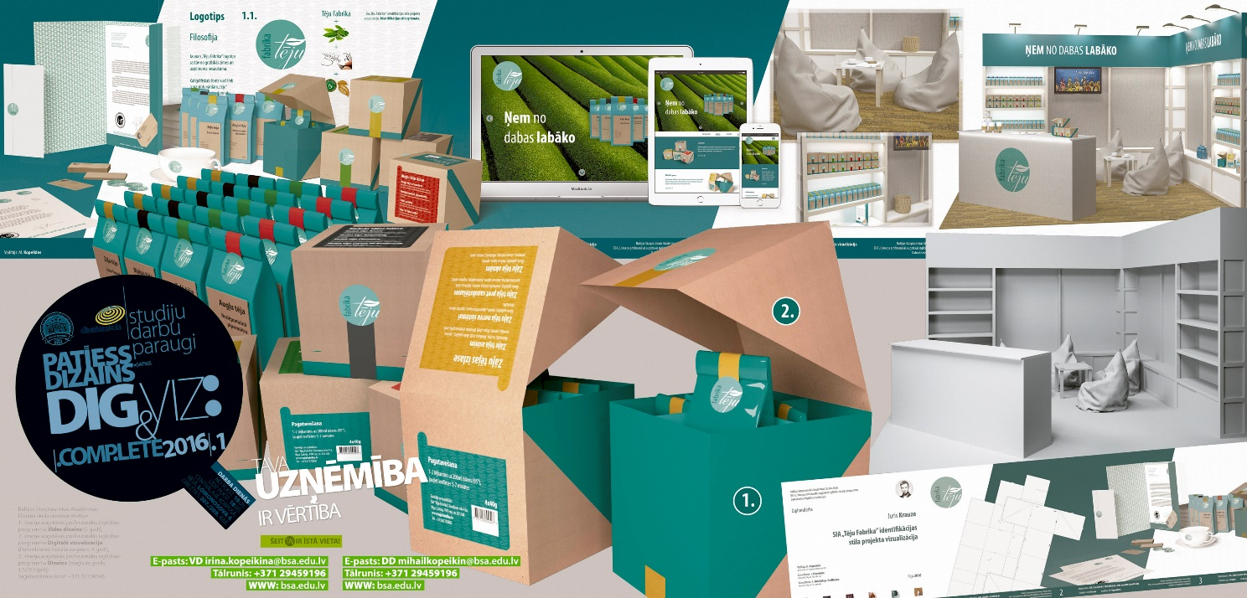

VIII INTERNATIONAL RESEARCH AND PRACTICE CONFERENCE
«CURRENT TRENDS AND TECHNOLOGIES IN DEVELOPMENT OF EDUCATION IN DESIGN WITHIN THE FRAMEWORKS OF THE BOLOGNA PROCESS»
to be held by Baltic International Academy on January 25, 2019, at at the address 4, Lomonosov str., Riga, Latvia

Participant's Name:
HEI / organization's full name and address:
Position:
Degree:
Academic title:
Participant's home address (including zip code):
Phone:
E-mail (optional)
Do you need an invitation /visa formalities | - yes | - no
Arrival date and time:
Reservations are needed: | - hotel  - economy class hostel  - no need
The dates of the stay: | - from |  | - till
Payment for | - Method of payment
Presentation, lunch on the first day and on the second day, cultural/social program, publication in Conference proceedings - € 50 | - by bank transfer  - the cash on the spot
Paper publication up to 20 000 printed characters € 25 | - by bank transfer  - the cash on the spot
Participation in the exhibition with projects, study works or course works € 25 | - by bank transfer  - the cash on the spot
Participation in a workshop | - by bank transfer  - the cash on the spot
Participate as a listener
(for the students and academics of BIA participation in the conference/ exhibition is free of charge)
The application must be sent electronically: | by the 10th of December, 2018 to the address  mihailkopeikin@bsa.edu.lv
Additional information
(if applicable)

