 | 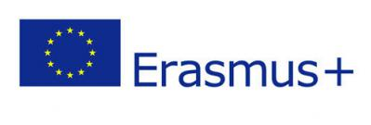 | 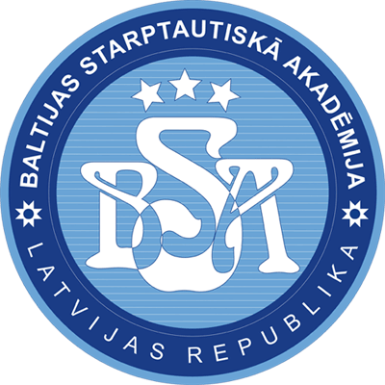
13th-14th May 2019
BALTIC INTERNATIONAL ACADEMY
Riga, Lomonosova str. 1/4, room 207
ERASMUS lectures of Dr. REGINA GARCIMARTÍN
professor of Procedural Law at the University of Zaragoza
13.05.2019.
- 9.30 - General view on Spanish legal system and courts
- 11.10 - Spanish experience in European Court of Human Rights
14.05.2019.
- 9.30 - Peculiarities of constitutional guarantees in Spanish Criminal Procedural Law
- 11.10 - Spanish experience in fighting economic crime

